**Cogs 536 Homework 2**

**AYSE OZDEMIR**

Dependent variables: PreTest, PostTest

Independent variable: Group

Group: Nominal

PreTest: Scale

PostTest: Scale

1. To make sure dependent variables are normally distributed, we can use Shapiro-Wilk test and check the p-value. If p-value is above 0.05, we can say that our dependent variables are normally distributed.

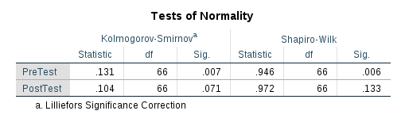  
  
  
  
  
  
  
  
p-value of PreTest; p<0.05 => There **is** significant difference between the PreTest and normal distribution.

p-value of PostTest; p>0.05 => There **is not** a significant difference between the PostTest and normal distribution.

Other results can be seen below:

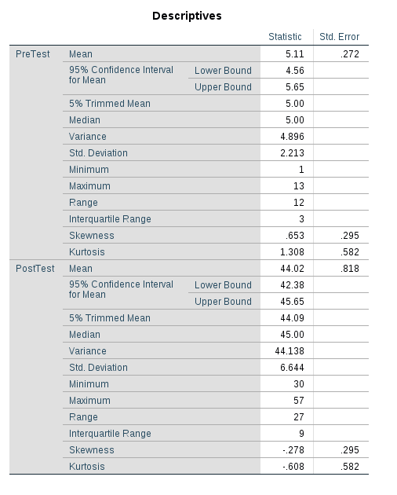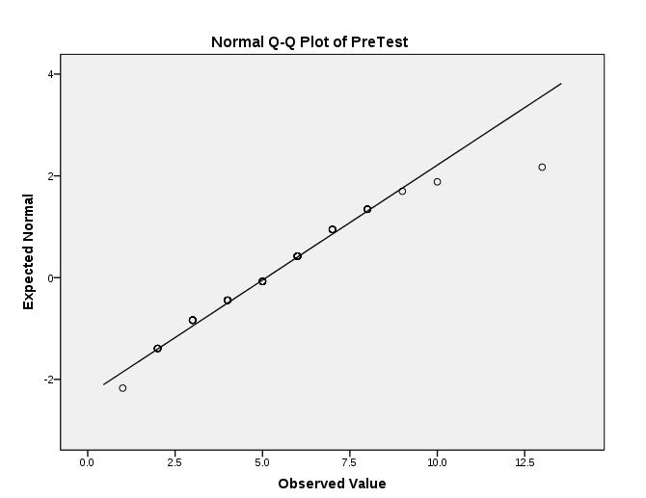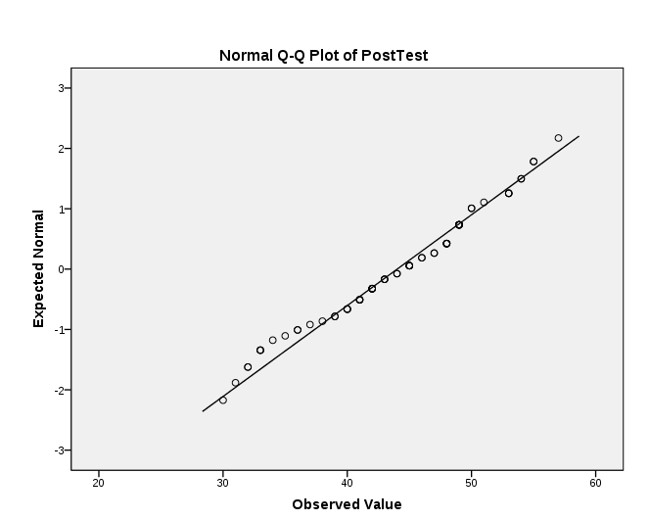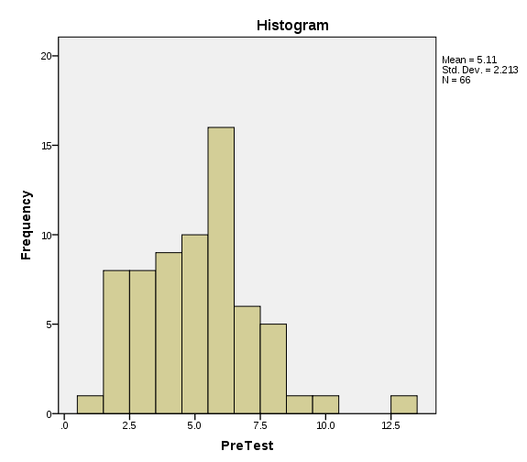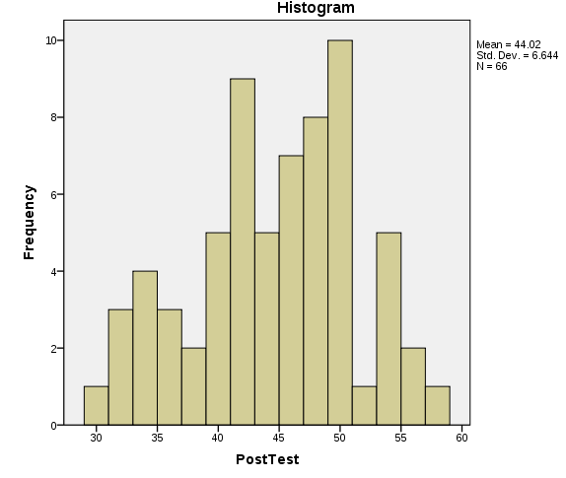

* 1. 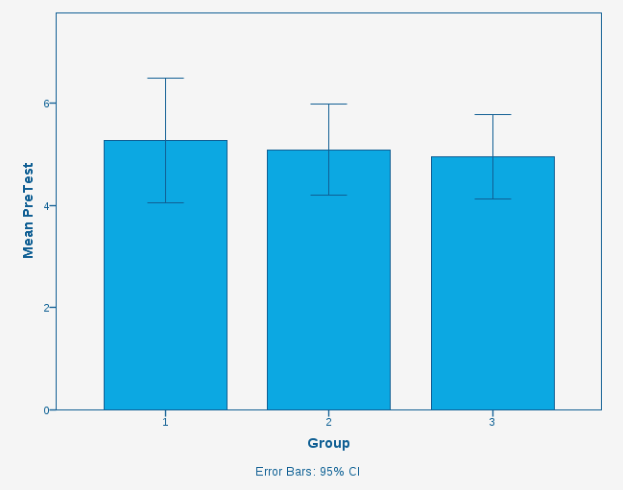  
       
       
       
       
       
       
       
       
       
       
       
       
       
       
       
       
       
     According to the bar graph, mean value of Group1 is bigger than others. Considering errors bars, the variability in Graph1 is again much more than other two groups. The variability in error bars tells us, there may be outliers in the data of Graph1. As error bars of Group2 and Group3 overlaps more, we can say data of Group2 and Group3 more similar to each other compared with Group1.
  2. 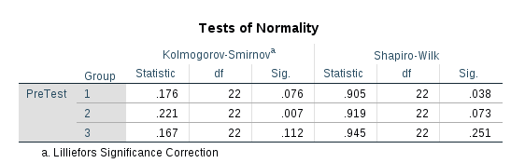  
       
       
       
       
       
       
       
       
       
     We have Kolmogrov-Smirnov test results, and Shapiro-Wilk test results produced. As The power of Shapiro-Wilk test to detect the differences is better than Kolmogorov-Smirnov test; we would prefer Shapiro-Wilk test results.

As the data is not normally distributed, we can not use ONE WAY ANOVA. We could use Kruskal-Wallis.

* 1. Null hypothesis (H0):   
     Data is normally distributed, and there **is not** a significant difference between the Group1, Group2, and Group3.

Research hypothesis (H1):  
Data is not normally distributed, and there **is** a significant difference between the Group1, Group2, and Group3.

We can reject the null hypothesis.

* 1. 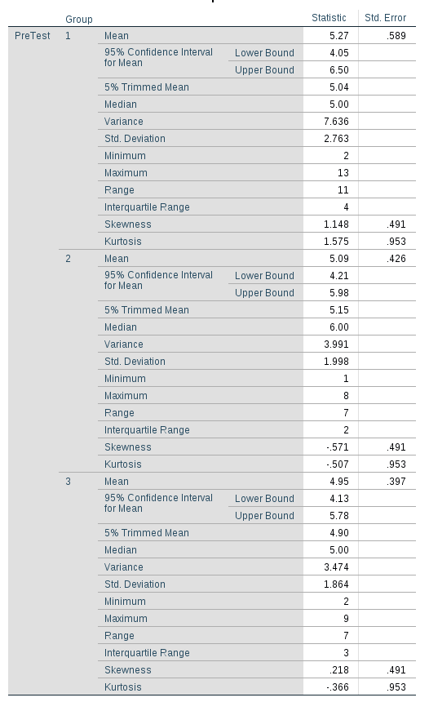

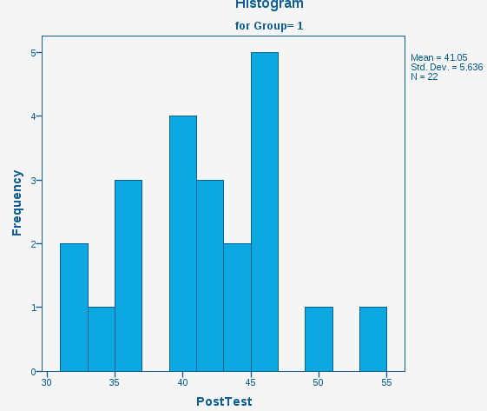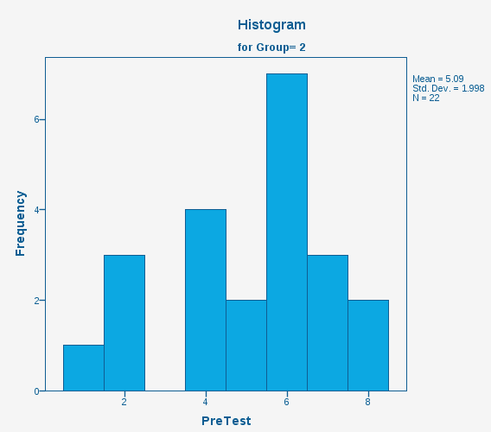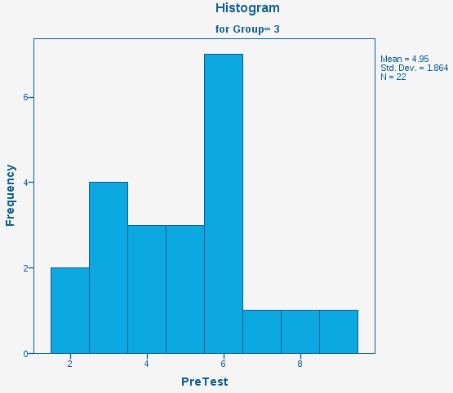

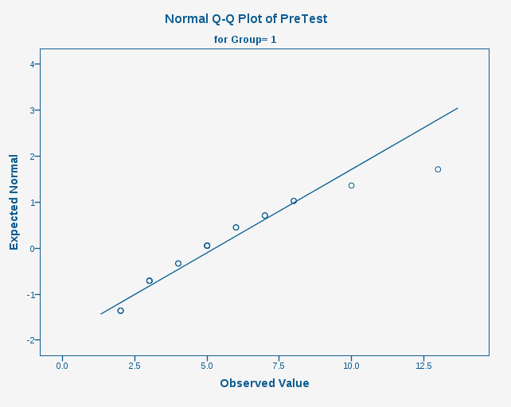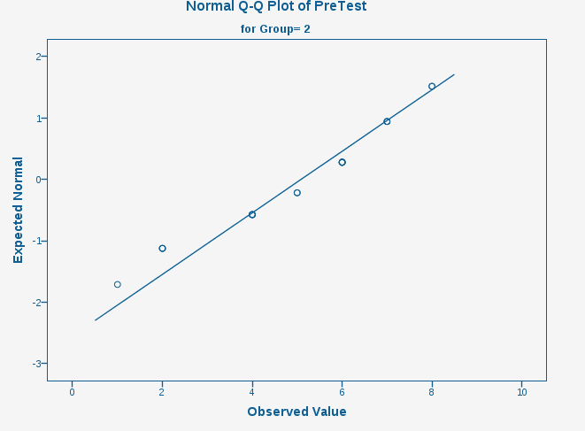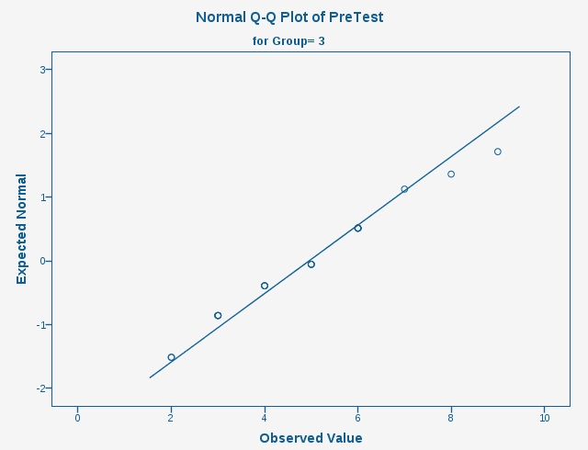

PreTest Skewness of z-values:

Group 1 : 1.148 / 0.491 = 2.33 not ok

Group 2 : -0.571 / 0.491 = -1,16 ok

Group 3 : 0.218 / 0.491 = 0.44 ok

PreTest Kurtosis of z-values:

Group 1 : 1.575 / 0.953 = 1.65 ok

Group 2 : -0.507 / 0.953 = 0.5 ok

Group 3 : -0.366 / 0.953 = 0.38 ok

PreTest shapiro-wilk p-value:

Group 1 : 0.038 not ok

Group 2 : 0.073 ok

Group 3 : 0.251 ok

Results for PreTest:

A Shapiro-Wilk’s test(p>0), and a visual inspection of their histograms, normal Q-Q plots and box plots showed that reading comprehension in children normally distributed for both Group2 and Group3, with a skewness of -0.571(SE=0.491) and a kurtosis of -0.507(SE=0.953) for Group2 and a skewness of 0.218(SE=0.491) and a kurtosis of -0.366 (SE=0.953) for Group 3. In Contrast, the normally distributed patterns could not be seen in Group1 data, with a skewness of 1.148 (SE=0.491) and a kurtosis of 1.575 (SE=0.953).

1. 1. 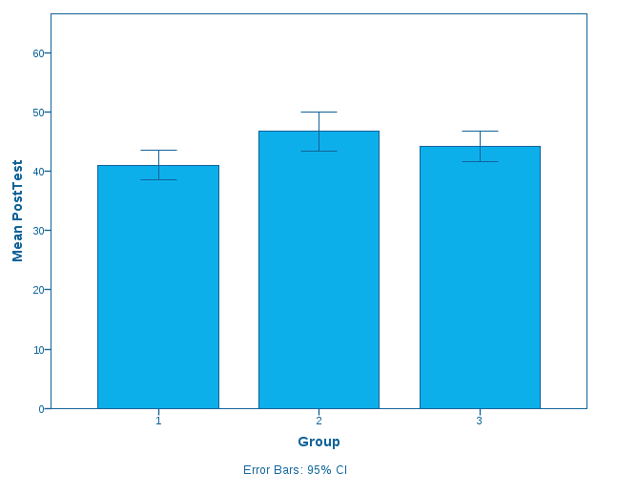   
        
        
        
        
        
        
        
        
        
        
        
        
        
        
        
        
      According to the bar graph, reading comprehension levels are more in Group2 as the mean value higher in Group2. As the size of error bars are small and they look like similar to each other. We can say there are small variabilities around means of all groups.
   2. 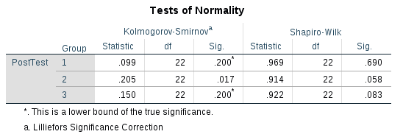Which test would be appropriate to test whether there is a statistically significant difference among the groups and why?   
        
        
        
        
        
        
        
        
        
        
        
        
      We have Kolmogrov-Smirnov test results, and Shapiro-Wilk test results produced. As The power of Shapiro-Wilk test to detect the differences is better than Kolmogorov-Smirnov test; we would prefer Shapiro-Wilk test results.

As the data is normally distributed, we can use ONE WAY ANOVA.

* 1. Null hypothesis (H0):   
     Data is normally distributed, and there **is not** a significant difference between the Group1, Group2, and Group3.

Research hypothesis (H1):  
Data is not normally distributed, and there **is** a significant difference between the Group1, Group2, and Group3.   
  
As the data is normally distributed, we can not reject the null hypothesis.

* 1.   
     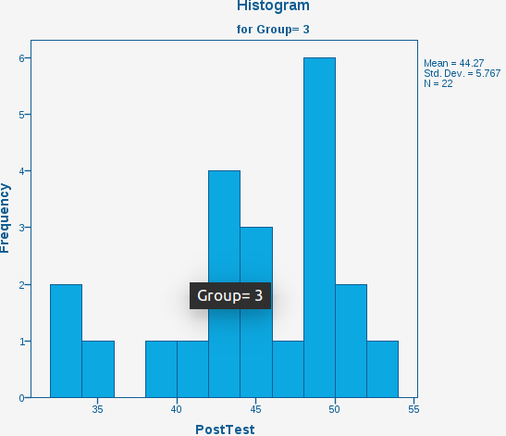  
       
       
     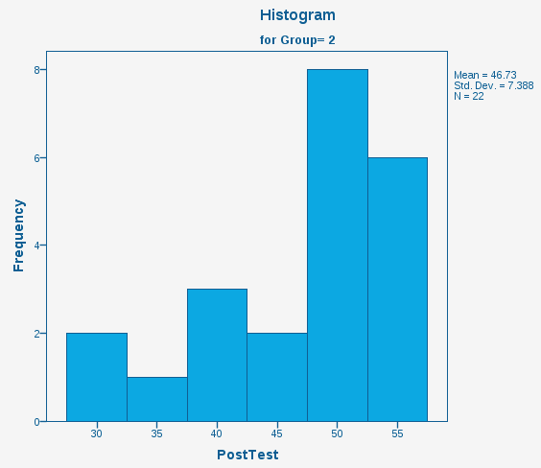  
       
       
       
       
       
       
       
     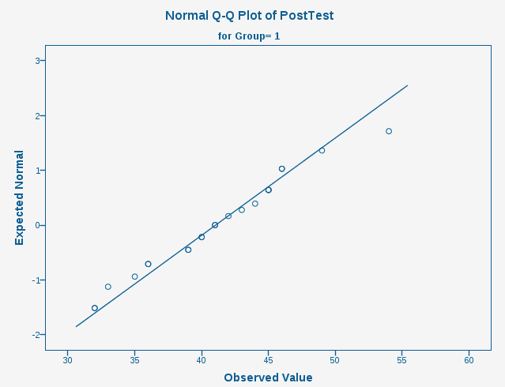  
     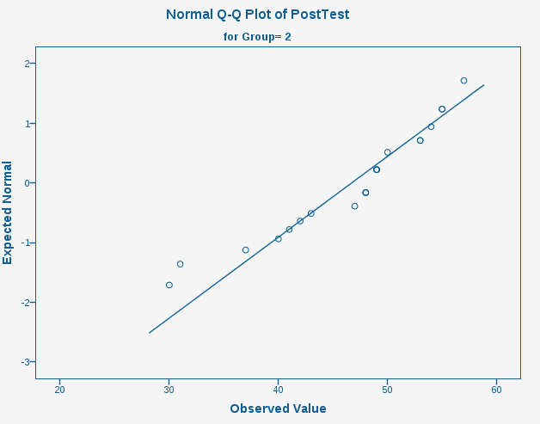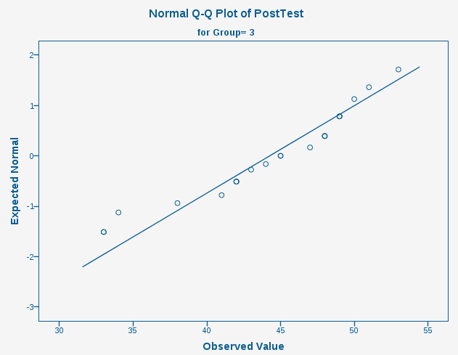  
       
       
       
       
       
       
       
       
       
       
     PostTest Skewness of z-values:  
     Group 1 : 0.188 / 0.491 = 0.38 ok

Group 2 : -0.904 / 0.491 = -1,8 ok   
Group 3 : -0.715 / 0.491 = -1.4 ok

PostTest Kurtosis of z-values:  
Group 1 : -0.509 / 0.953 = -0.53 not ok  
Group 2 : 0.324 / 0.953 = 0.33 ok  
Group 3 : -0.257 / 0.953 = 0.26 ok

PostTest shapiro-wilk p-value:

Group 1 : 0.690 ok

Group 2 : 0.058 ok

Group 3 : 0.083 ok  
  
  
  
Results for PostTest:

A Shapiro-Wilk’s test(p>0), and a visual inspection of their histograms, normal Q-Q plots and box plots showed that reading comprehension in children normally distributed for all groups, Group1, Group2 and Group3, with a skewness of 0.188(SE=0.491) and a kurtosis of -0.509(SE=0.953) for Group1, a skewness of -0.904(SE=0.491) and a kurtosis of 0.324(SE=0.953) for Group 2, and a skewness of -0.715(SE=0.491) and a kurtosis of -0.257(SE=0.953) for Group 3.

1. 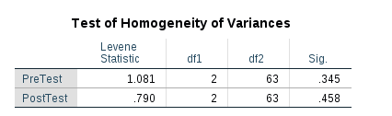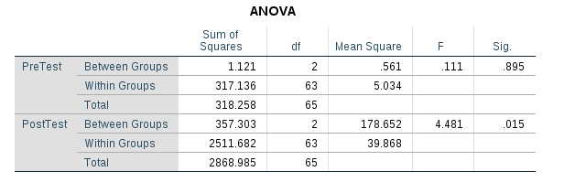   
     
     
     
     
     
     
     
     
     
     
     
     
     
     
     
     
     
     
   F(2,63)=0.111, p>0.05

F(2,63)=4.481, p<0.05